DEMAR MCKOY

MARS

MARS IS THE FOURTH PLANT FROM THE SUN.

THE DIAMETER IS 6,794KM.

THE DISTANCE IS 227,940,000KM

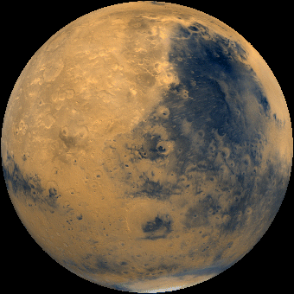
IT WAS 75.98M FROM THE SUN

