18 April 2007
D. Cohen

Testing the new (6.2.2.beta) version of Spect3D – ultimately calculating a wind opacity model with the new “opaque emitter” option.

But first, we’re setting up a calculation with no radiation boundary conditions, a simple atomic model (ground states only, three elements only), and a simple kinetics model (LTE). Once we get sensible results from this, we’ll evolve the calculation to one using CRE, an inner radiation boundary condition, and eventually, a full array of cosmically abundant elements.

First, we set up three atomic model files (.atm):

Start with just H, He, O – ground states only; Atomic Model Builder 2.8.4, using ATBASE v.6.0

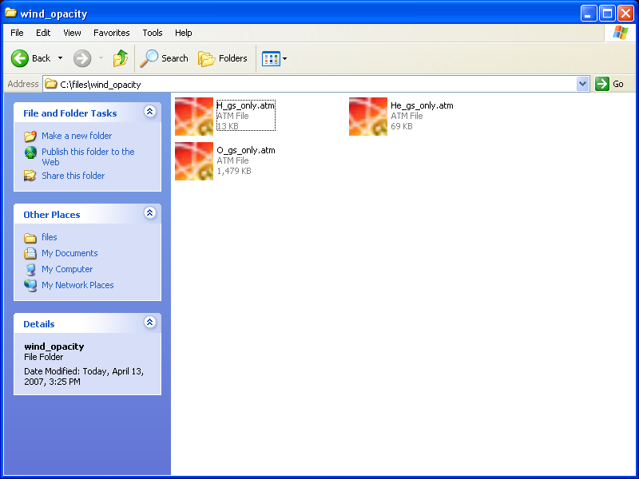

Next, we set up a plasma grid, writing out an exo file for Spect3D to use as an input. Here’s the documentation of this grid:
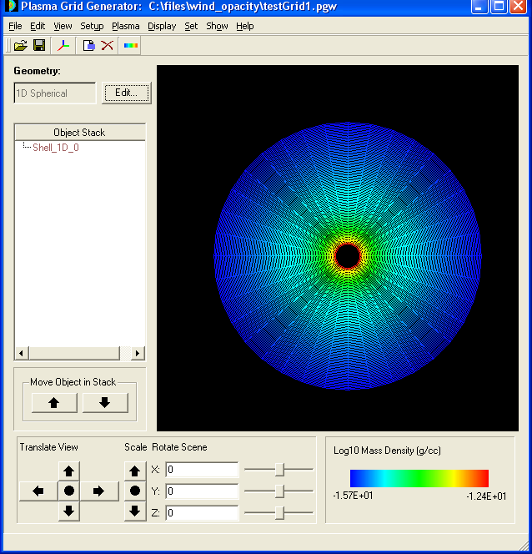

Materials tabs:

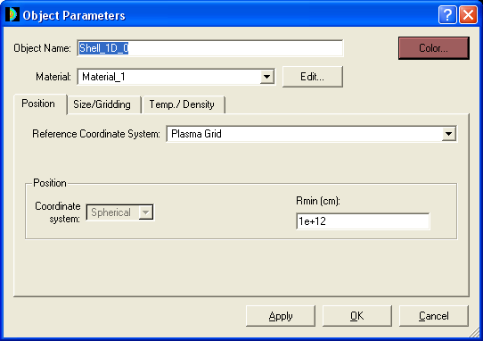

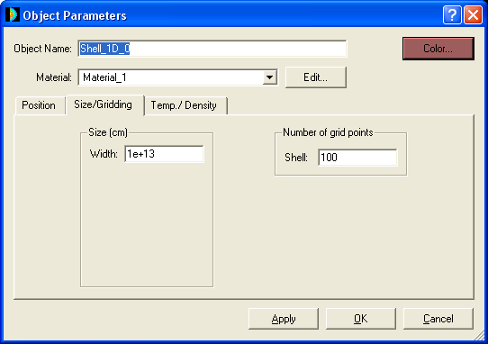

NOTE: Is there a way to have the grid be logarithmic? Then we could get away with many fewer points on the grid.

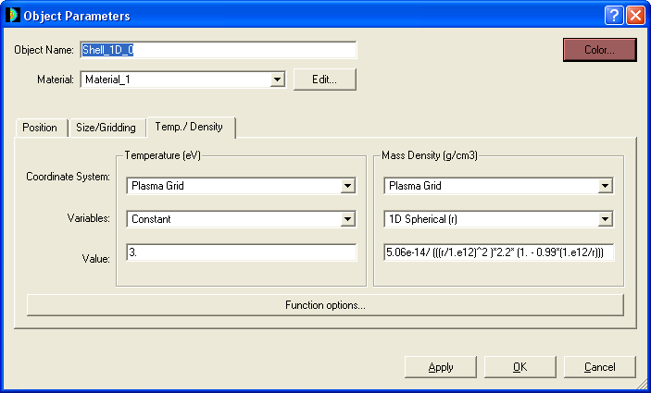

NOTE: temperature appears to have to be in eV. In Spect3D, there’s an option for temperatures in deg-K. Having that here too might be nice (but this isn’t crucial by any means).

NOTE also: the mass density values are sensible. I have done a spot check of several grid zones (see example below), and also plotted this function on my own and it checks out. The 1e12 is the inner grid boundary (and also the stellar radius). You can see the cgs mass density range in the color bar on the wire mesh plot above.

Here’s a zoom-in on the center of the grid, with one cell highlighted.

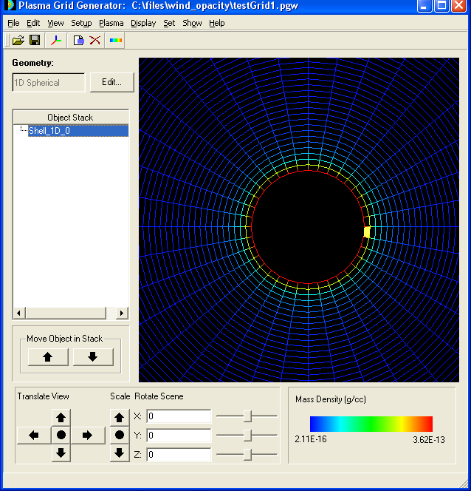

And the properties of the highlighted cell:

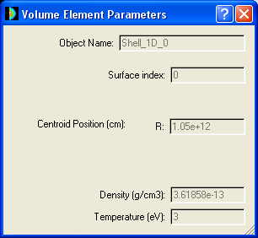

OK, wrote out an .exo file from this plasma grid.

OK, now setting up the Spect3D simulation using the atm and exo files described above:

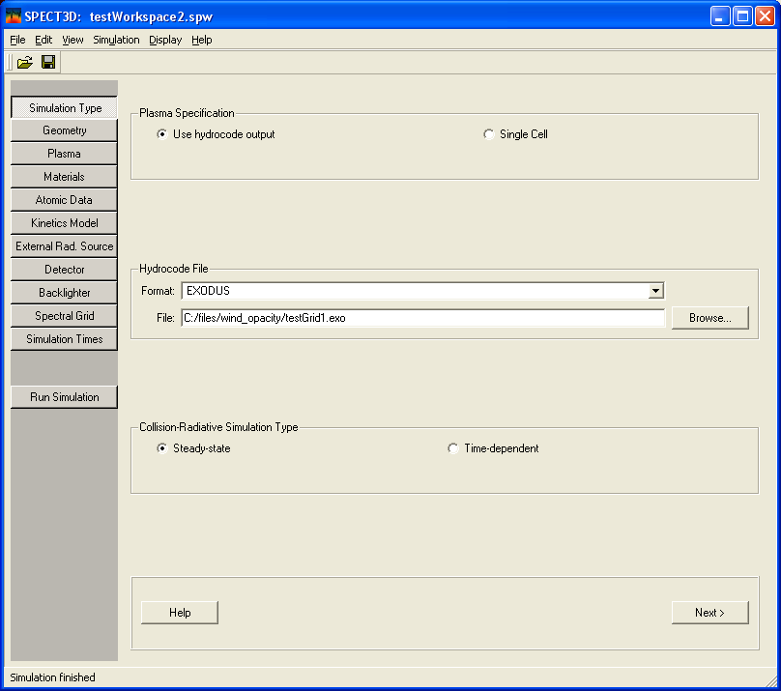

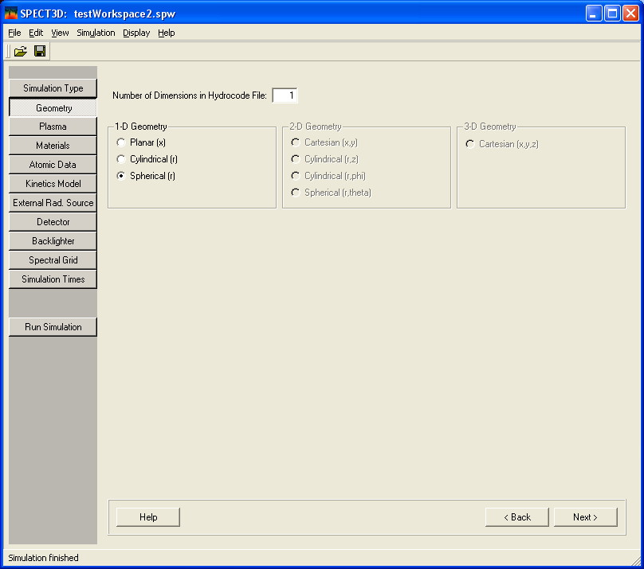

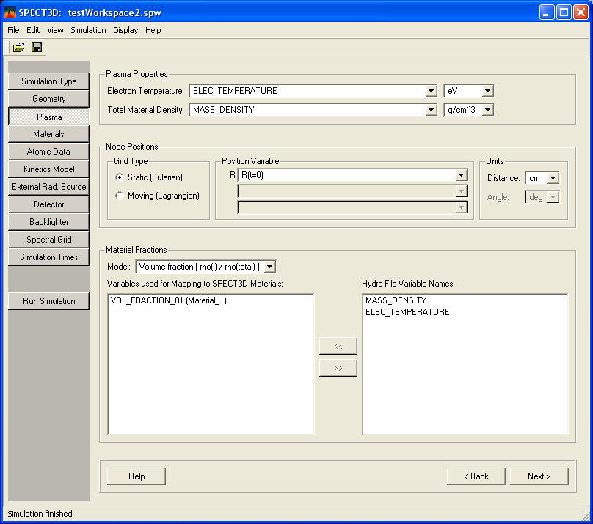

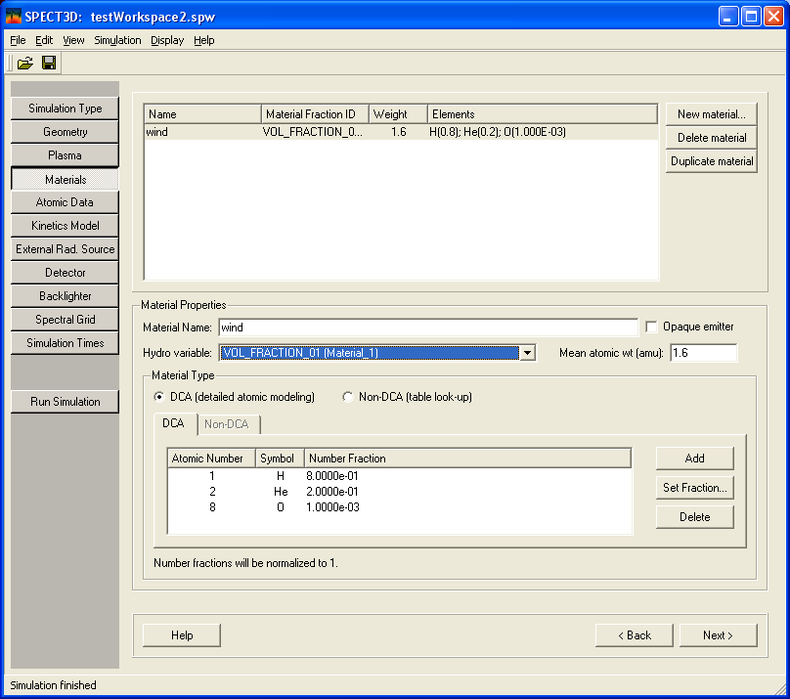
NOTE: I have NOT yet used the “opaque emitter” option. I’m just trying to get a simple simulation to run, and then we’ll go from there.

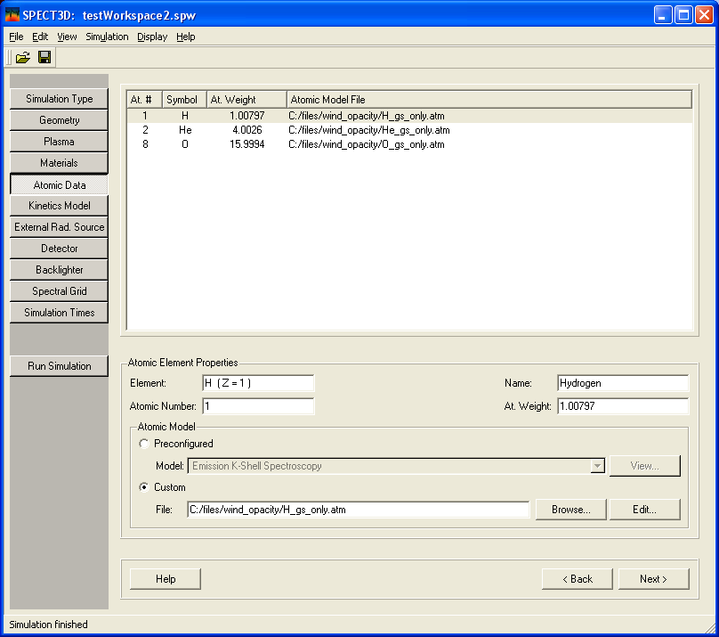

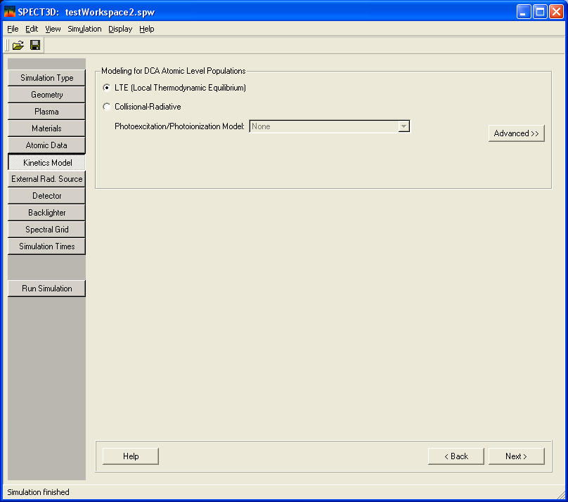
NOTE: Just using LTE here at first.

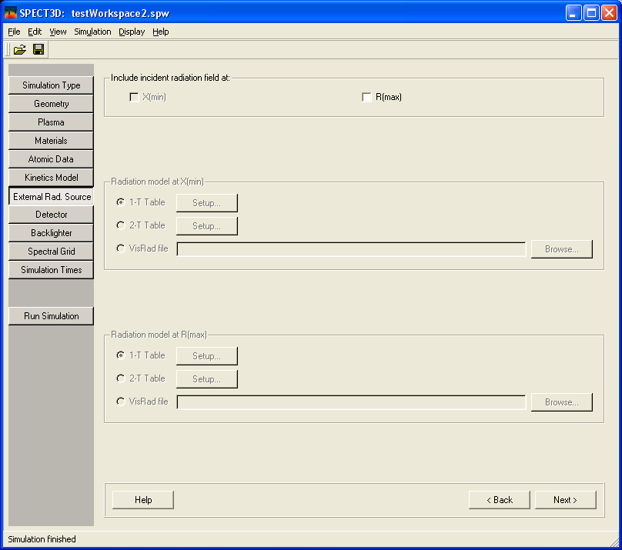
NOTE: And here too, no external field at first.

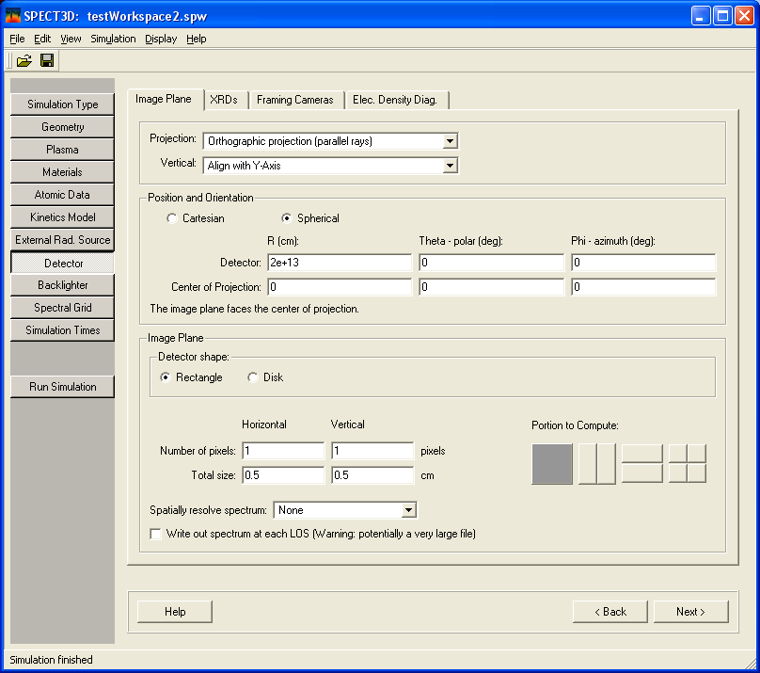
NOTE: I’m slightly concerned that I haven’t set this up correctly. Does the choice of Vertical=Align with Y-axis make sense? Is the point that it’s just got to be orthogonal to the R-axis (which I’m assuming takes on the X-axis label)?

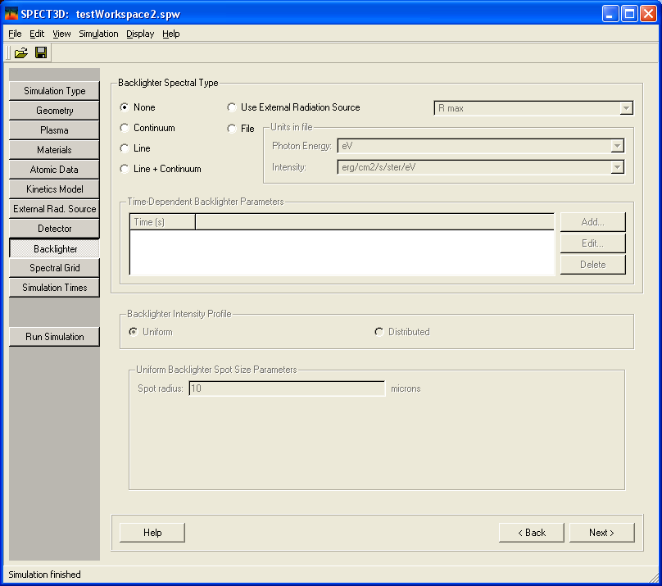

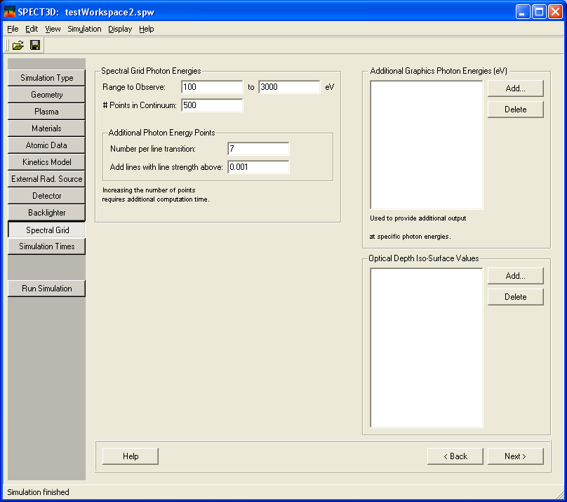

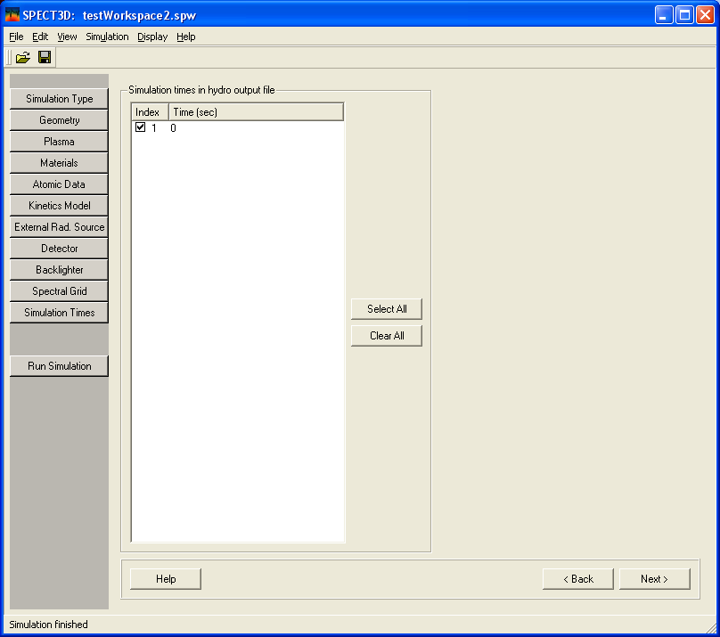

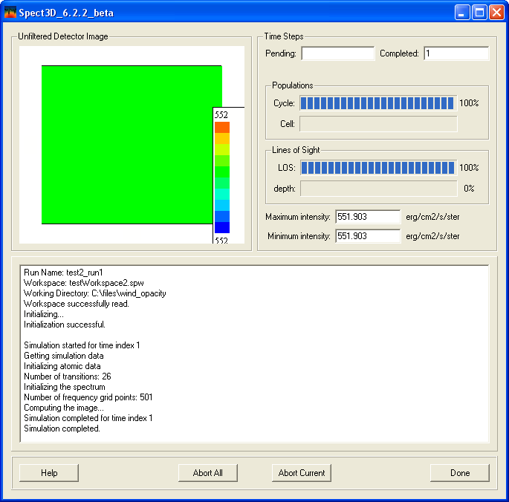

Looks OK, but when I try to open the results in the visualizer, I get this error message:

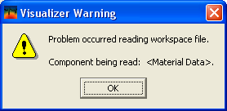

Any idea what’s wrong? All the relevant files are in: http://astro.swarthmore.edu/~cohen/projects/wind_opacity/

