Aperture Photometry and Transit Light Curve Analysis
D. Cohen and E. Jensen
(v.1.0 January 13, 2015)

This document assumes familiarity with Image reduction and analysis at the Peter van de Kamp Observatory and also the Relative Photometry instructions.

Context

This follows on to the WASP-11 light curve analysis, providing practice with another, somewhat more difficult to analyze, dataset and also includes a section on fitting a transit model to the light curve.

Practical Information

This exercise is adapted from the final lab the Astro 16 class did in fall 2014. It involves looking for and characterizing a transit-like event in the light curve of a candidate transiting exoplanet host star, as identified by the KELT consortium, of which Swarthmore is a part.

Some information about KELT here:

http://www.astronomy.ohio-state.edu/keltnorth/Home.html

The data were taken on the night of November 21, 2014. You can download the data here:

http://astro.swarthmore.edu/~cohen/telescope/KELT33095.zip

These data (120 images each with an 80 second exposure time) have already been reduced. You can load them into an image stack in AIJ and open up the photometry utility and start doing your aperture photometry (as detailed in the Relative Photometry document that you’ve already gone through).

But do take a look at the headers of some of the first and some of the last images and look, specifically, at the airmass. The field was very low at the end of the observing.

Take a look at the field and also compute an airmass plot using TAPIR.

http://astro.swarthmore.edu/finding_charts.cgi

http://astro.swarthmore.edu/airmass.cgi

Below is part of the KELT target output from TAPIR; our star is the second one in the table. You can use its RA and Dec to make either a finding chart or an airmass plot (Nov 21, 2014 to reproduce the airmass vs. time for our observation).

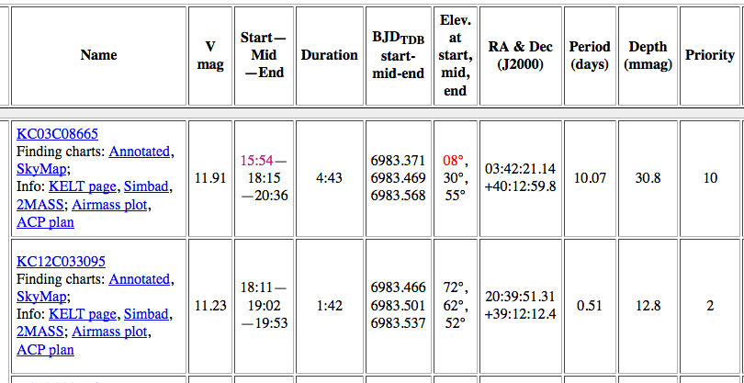

For your convenience, here are the airmass plot (with expected transit time indicated) and finding chart:

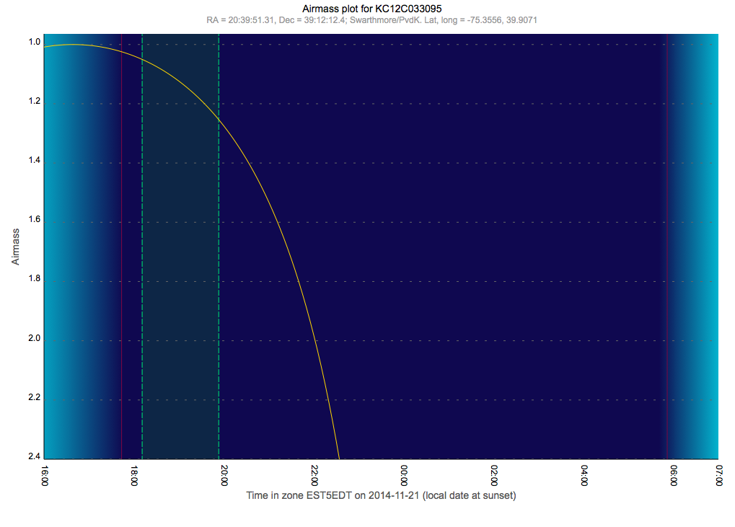

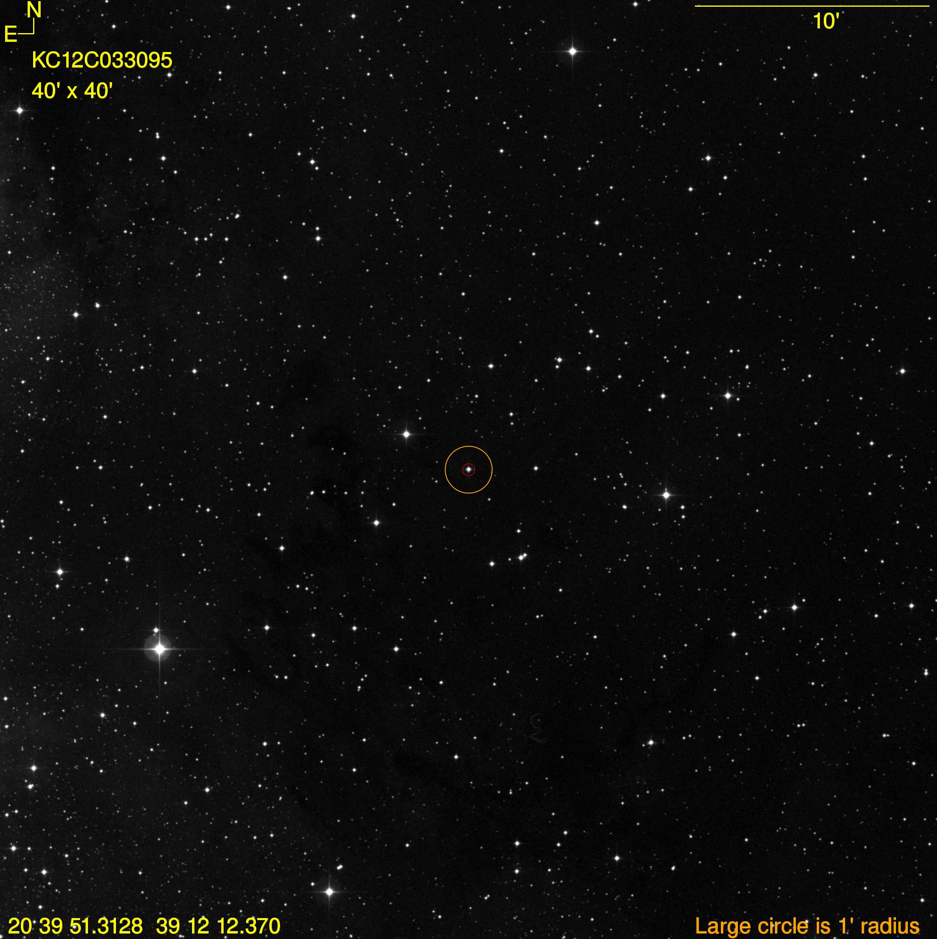

Note that you’ll need the finding chart to figure out which star is the target star in your data.

Procedure

You can follow the instructions for aperture photometry in the previous document (WASP-11) to create a light curve for the target star.

Here are some additional tips:

You can draw vertical lines to mark the predicted ingress (beginning of the transit) and egress (end of the transit). The controls for this are at the top right of the “Multi-plot Main” interface that opens up when your lightcurve is finished being plotted.

Be careful/consistent/organized with your “Norm/Mag Ref,” Scale, and “then Shift” settings so you can display all your comp star light curves on the same plot as your target and see their interrelated trends.

Note that the “Norm/Mag Ref” setting that uses both or either outer-third of the light curve can be further controlled by using the “Fit and Normalization Region Selection” at the bottom center of the Multi-plot Main interface.

Use the “Bin Size” column in the “Multi-plot Y-data” interface to experiment with different binnings. Some binning is probably warranted in order to smooth out some of the noise.

In the Multi-plot Y-data interface, near the left, you can use the “Y-data” pull down menus to plot all sorts of things, including the total comp star counts and the airmass. You could then scale the airmass by a negative number so it mimics the brightness changes expected from varying airmass. You can even scale it (by trial and error) to the total comp star counts to see the extent to which the latter quantity tracks the former (places where it doesn’t are likely times where there were light clouds, and so that can alert you to parts of your target light curve that might be less reliable than others).

More on this: You can plot the airmass and total comp star counts (tot_C_cnts) (see my annotated screen shot, below: two-headed arrow); Note that I scaled the airmass with a negative number and also I checked the "Page Rel" box for the airmass and tot_C_cnts data (this makes the scaling and shifting relative to the page's vertical range, not to the actual values of the data, and interprets the input scale and shift numbers as percentages).

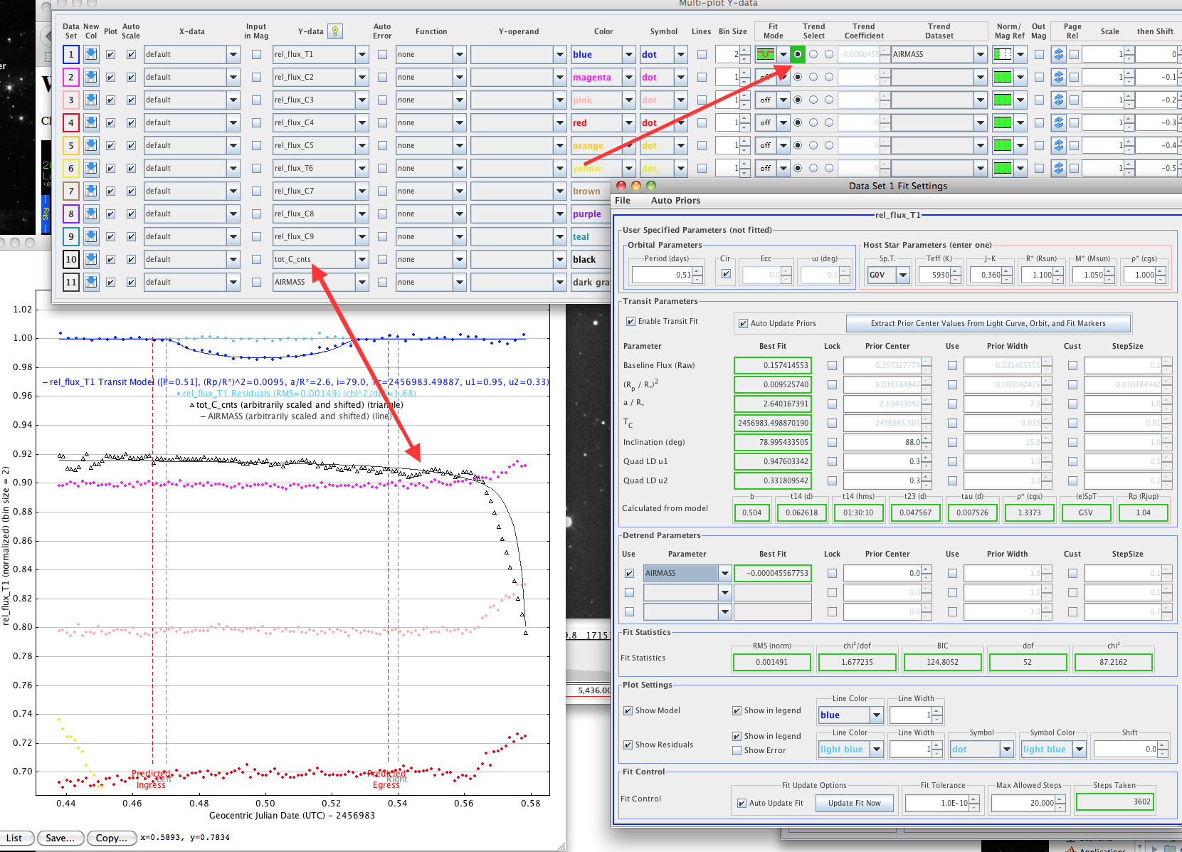

- You can de-trend the light curve by the airmass (i.e. divide the light curve by the airmass curve); see the arrow pointing at "Trend Select" (above; right arrow). You will have to choose "AIRMASS" from the pull down menu ("Trend Dataset"). Note that you can de-trend using other variables, in principle. The "Fit Mode" doesn't need to be set to transit fitting, as it is in the screen shot (more on that in a minute, below). You can detrend just based on the out-of-transit data - give it a try. And then you can switch to the transit fit mode via the little pull-down menu. It will both detrend and fit at the same time. Then, note that the detrend parameters are listed in the window that shows the transit fitting parameters.

- By choosing the little cartoon of the transit in the “Fit Mode” pulldown menu, AIJ will automatically fit a transit model to the light curve of the target star. Note that this opens (yet another) AIJ window (visible in the lower right of the screen shot shown on the previous page). That window contains, among other thing, the ratio of the planet to star radii (which is derived from the fitted depth), and the size of the orbit and the inclination of the orbital plane with respect to our line of sight. These last two quantities combine to tell us the path the planet takes across the face of the host star. In this case, the path is not across the equator/middle of the star, which you can already figure out since the transit is not flat-bottomed. There is also a chi-square value (indicating the goodness of fit) and various parameters related to the star that also control the properties of the best-fit model.

- You can look in the measurements table (that the AIJ photometry creates) and find the values of the airmass (or any other parameter) and the altitude. Look how low the telescope was pointing for the last few images! You can trim off the points at either end of the light curve. See the screenshot below (arrow pointing at "Trim Data Samples"; and note the tail of the arrow is at the last displayed data points in the light curve, but there are several missing - not shown, but still computed, but - importantly - excluded from the light curve fitting).

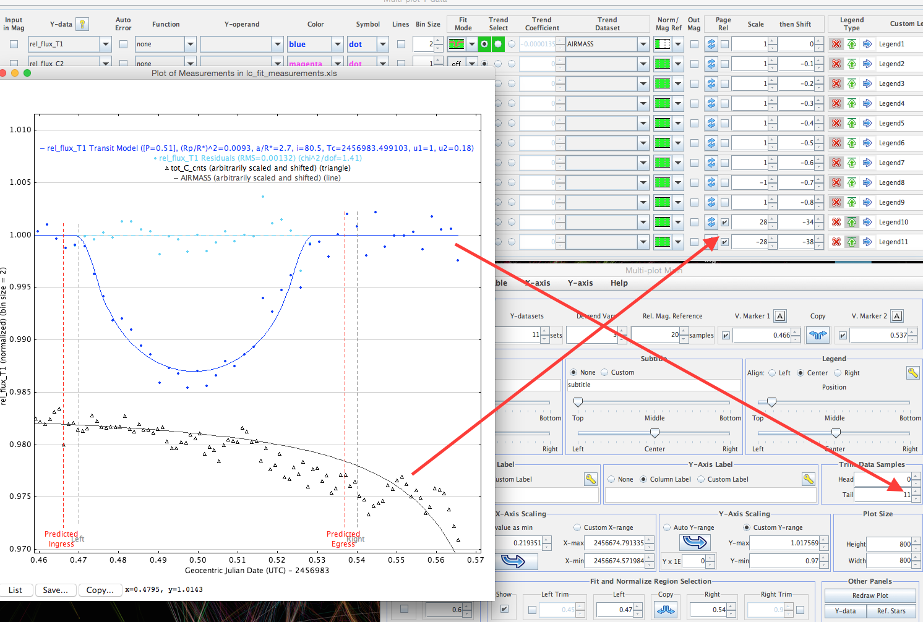

- In that screen shot, the other arrow points at the Page Rel check boxes for the airmass and tot_C_cnts.

- Definitely explore the Multi-Plot Main menu interface (where you set the x- and y-axis ranges). It has many, many useful features. For example sliders to control the legend placement.

- Also there, the "fit and normalize region selection" is how you tell the detrending which parts of the light curve the green triple panels in the "Fit Mode" and "Norm/Mag Ref" pull-down menus refer to.

- And from the Multi-plot Main interface, the File > Save All option will save about six relevant files. This includes a measurements.xls file. When you close and then reopen AIJ, you can drag that file onto the Multi-plot Main menu and it will restore your session. To see your apertures, you can just open an image and drag the saved apertures file onto it and they will show up.

- Those new dots that appear when you fit the transit, around 1.00 but above the transit itself, are the fit residuals (i.e. the ratio (or maybe scaled difference) between the data points and the model (the line)). Unfortunately, the default symbol for the residuals is the same as for the data. But you can change that (or even choose not to show the residuals) via a check-box in the transit-fitting interface.

http://astro.swarthmore.edu/~cohen/telescope/telescope_data_reduction_and_analysis_v1.2.pdf
http://astro.swarthmore.edu/~cohen/telescope/photometry_notes_fall2014_v1.pdf

