Aliya Tianna Tanner

VENUS

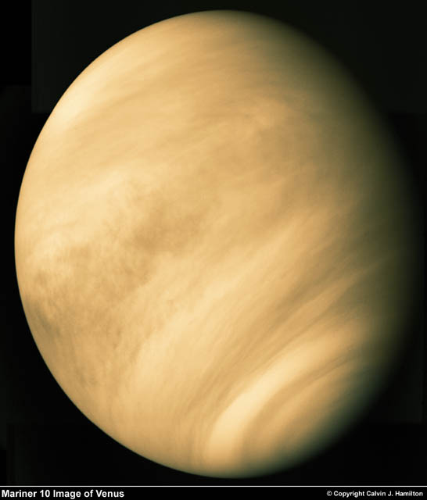

The actual diameter is 12,103.6 km. The actual distance from the sun is 108,200,000 km. 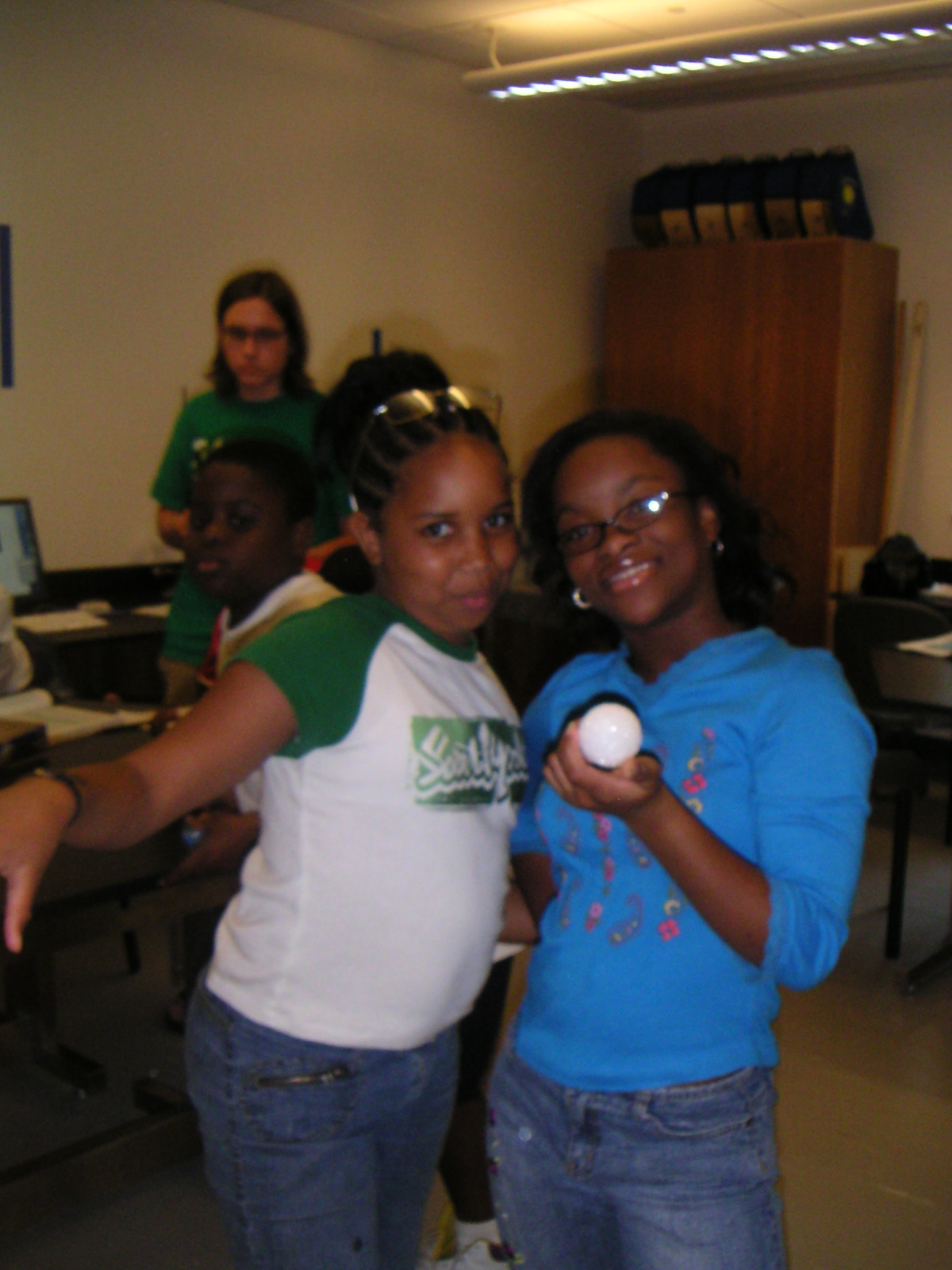

The model diameter is 1.21036 mm. The model distance is10.82 m.
Venus is the third brightest object in the sky.

