19 April 2007
D. Cohen

Test from yesterday, with only one material and NO opaque emitter – after Pam sent new visualizer:

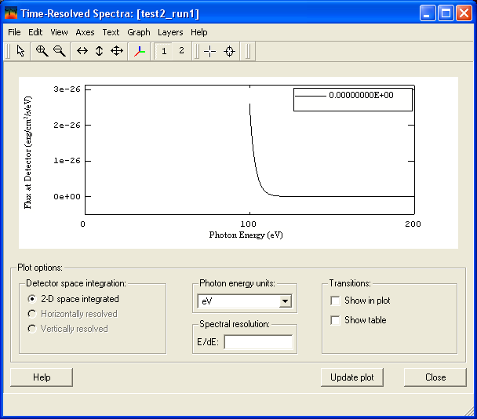

OK; this is reasonable – emission spectrum of a 3 eV LTE plasma at >100 eV.

Now, using the opaque emitter option -

Pam says we do need to set up a second material in the PlasmaGridGenerator, though its properties don’t matter.

So, I copied our original plasma grid workspace, and am modifying that:

Setting up a new object, with a new material:

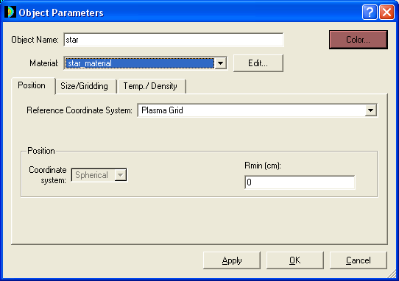

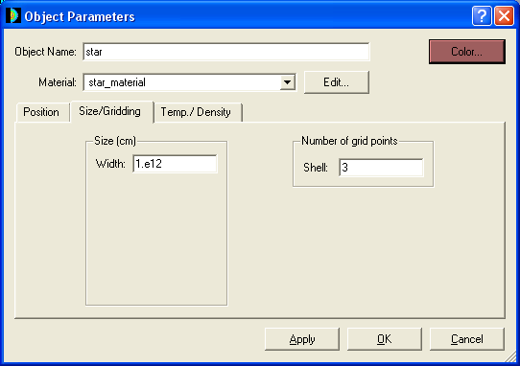

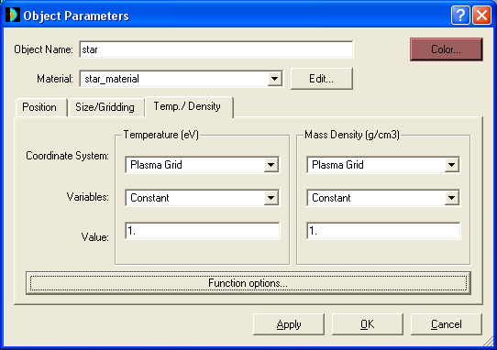

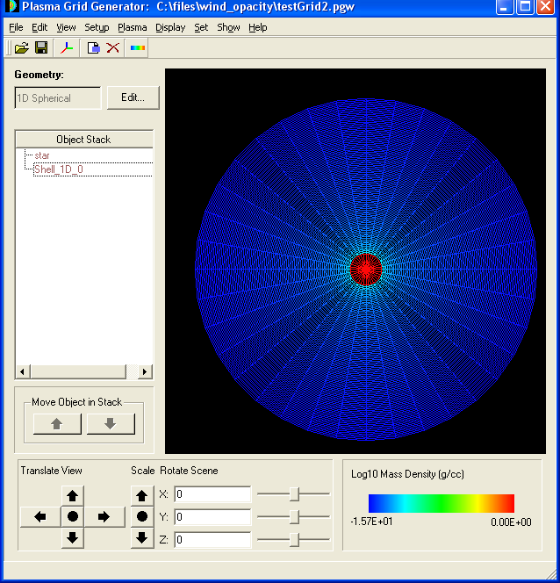

Note that the density scale is all stretched now, since the “star” is set to rho=1.

Exported netCDF to testGrid2.exo

Now, modifying the Spect3d workspace: testWorkspace2.spw:

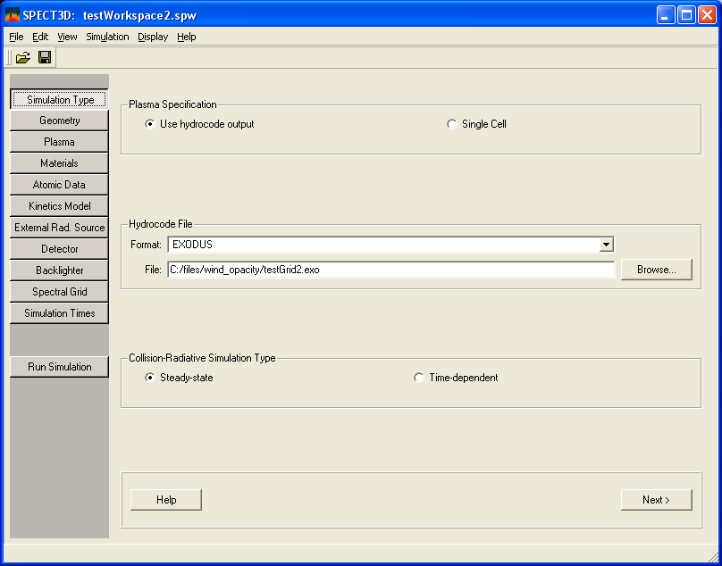

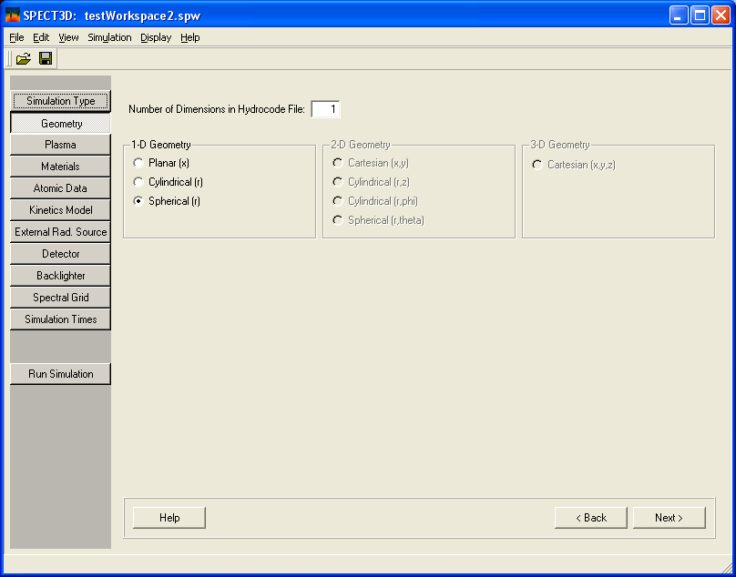

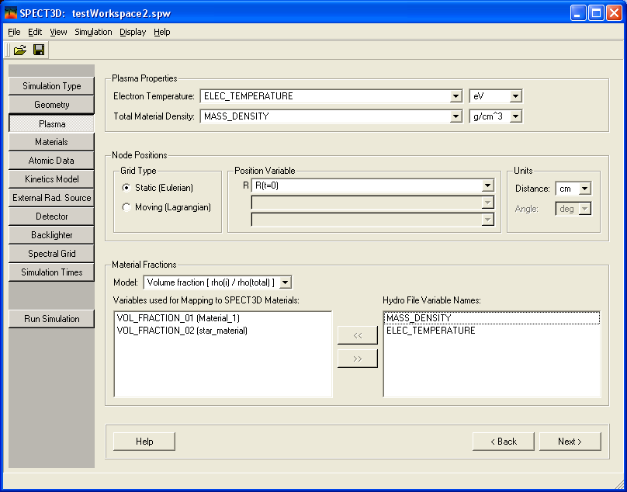
NOTE: “star_material” added for Vol_Fraction_02 as a material to be mapped

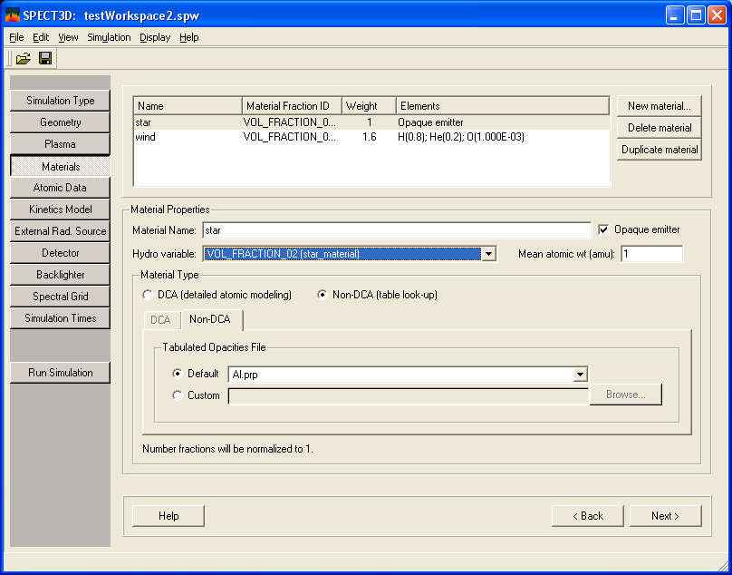
NOTE: This is the new material tab setting for the opaque emitter = the star; wait! Don’t want tabulated opacities; want external radiation – had to uncheck the opaque emitter box and then re-check it; now have:

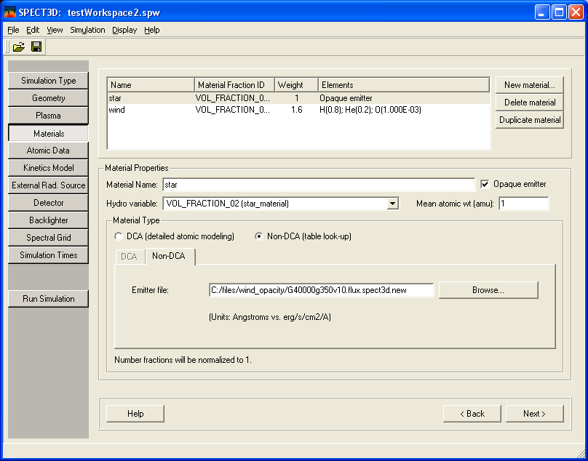

NOTE: The emitter file is a TLUSTY model atmosphere for zeta Pup. It actually comes in nu vs. H_nu units. There’s a small IDL code on Ruby: /home/cohen/Maurice/*.pro for doing the conversion to lambda vs. H_lambda.

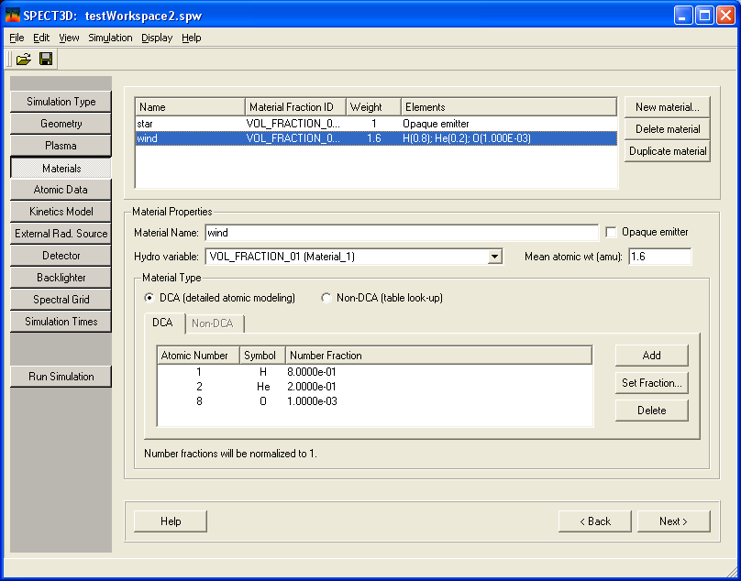
And this is the (same old) material tab set up for the wind

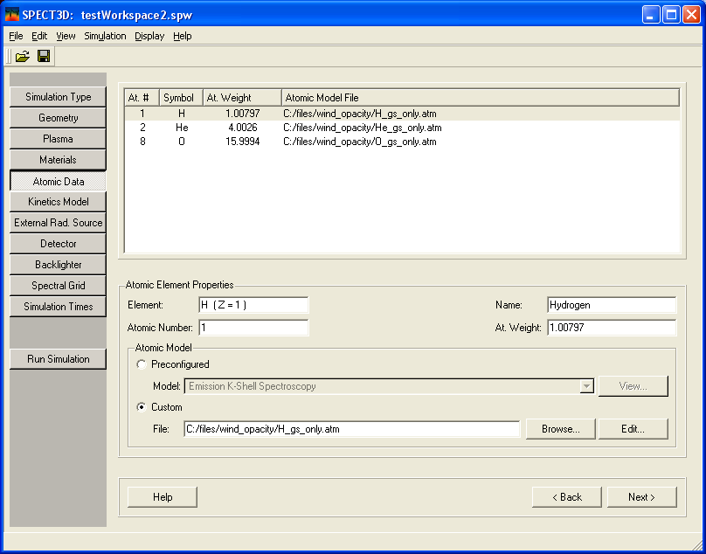

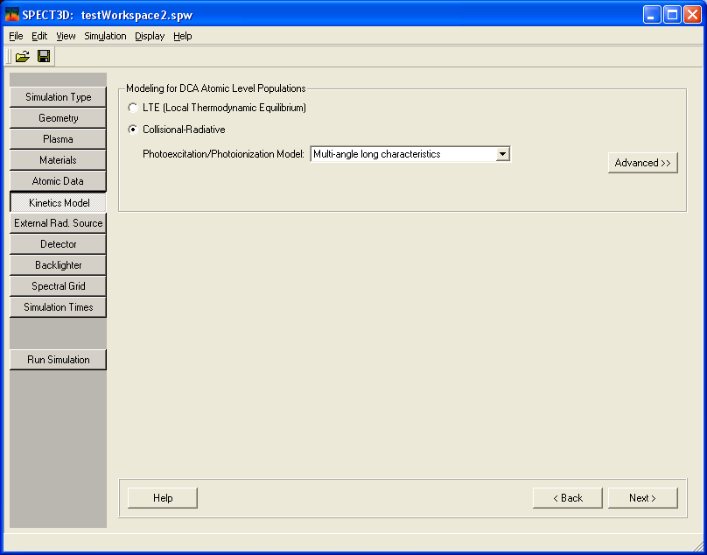
NOTE: CR with a multi-angle photoionization model

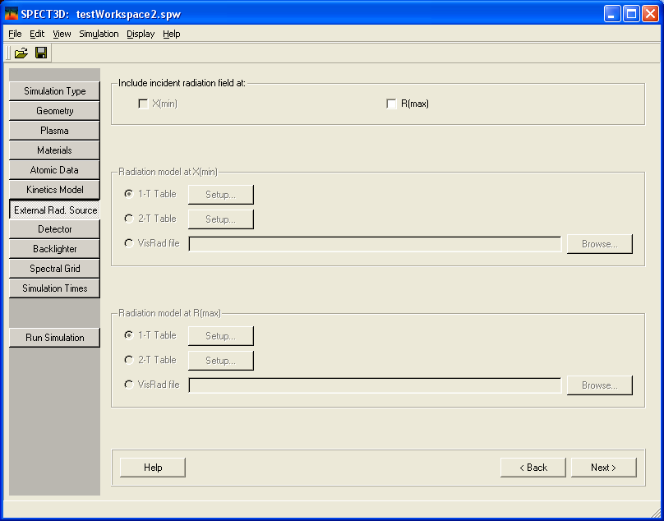
NOTE: No external radiation source, as such; all this is handled in the opaque emitter interface.

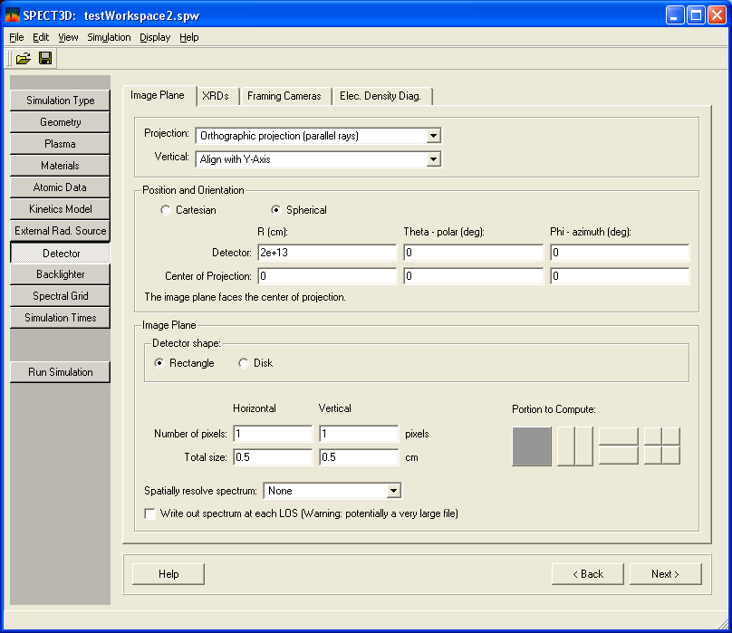

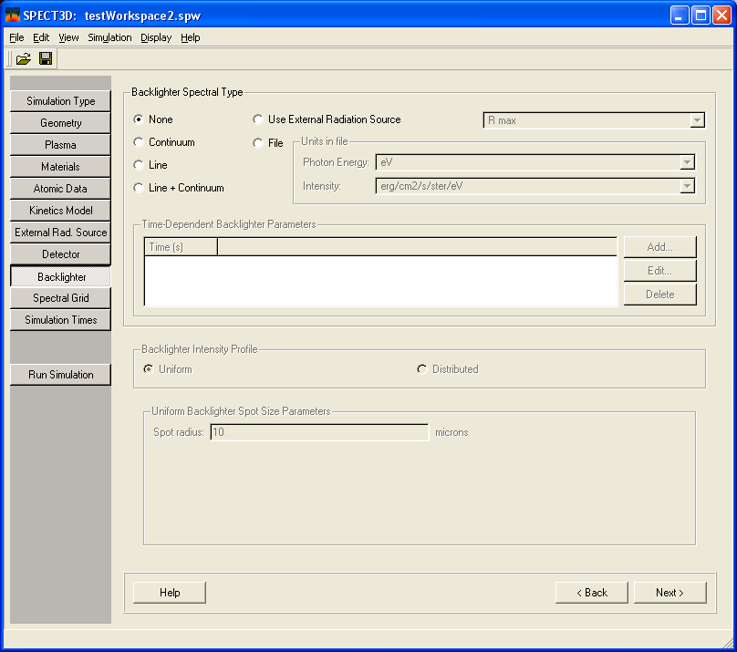

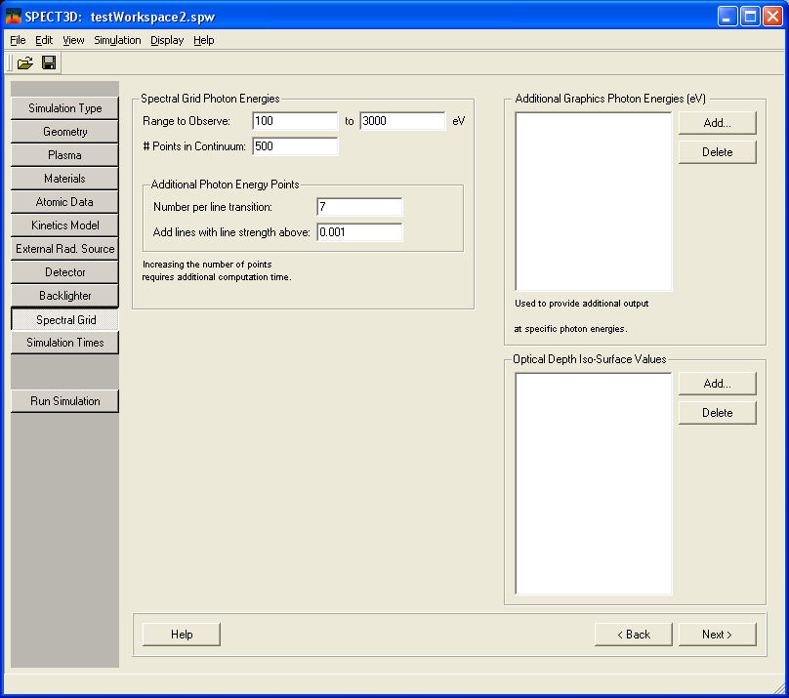

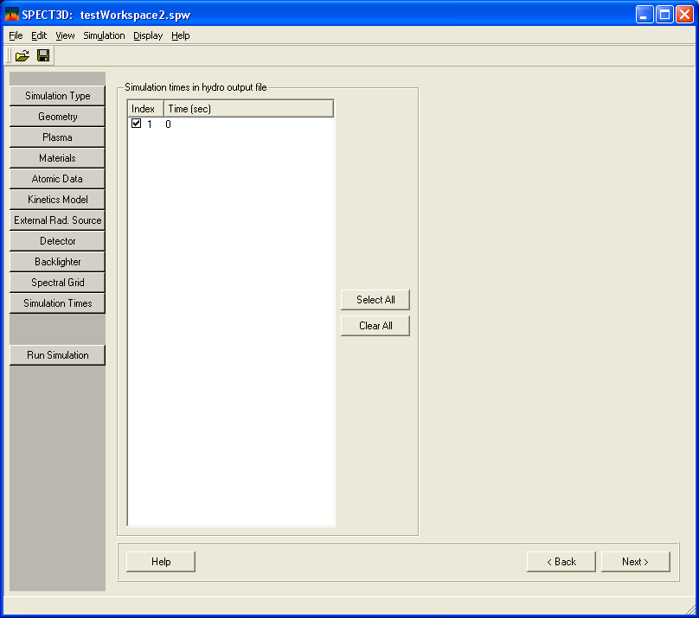

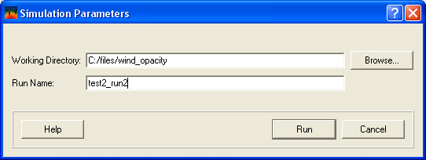

After a few seconds – and with interface messages indicating only that files are being read – Spect3D crashes without an error message. The application closes.

All files are in: http://astro.swarthmore.edu/~cohen/projects/wind_opacity/
Note that except for a copy of the workspace, the results folder is empty for this run.

