Relative Photometry with data from the Peter van de Kamp Observatory

D. Cohen and E. Jensen

(v.1.0 October 19, 2014)

This document assumes familiarity with *Image reduction and analysis at the Peter van de Kamp Observatory*[1].

Context

Our goal is to measure the relative brightness of one star (the *target*) from one observation to the next in order to produce a *light curve* – a plot of relative brightness vs. time. Stars with transiting exoplanets will get dimmer (by roughly 1%) for a period of several hours when their planets pass in front of, or *transit*, their *host star*. We try to discover previously unknown exoplanets around interesting stars, and once discovered, the *transit depth* (the fractional decrease in host-star brightness) tells us the ratio of the planet’s size to the star’s size.

Some papers with transit light curves from our observatory are posted on the observatory website: <http://www.swarthmore.edu/peter-van-de-kamp-observatory/research>.

Practical Context

We typically have a sequence of many short observations of a single star (plus all the random stars that appear nearby it in the sky), and reduce those data exactly as you have done with your images (e.g. of the Dumbbell Nebula or the Whirlpool Galaxy), by applying flat-field, dark, and bias corrections (in *AstroImageJ* – *AIJ*). This produces, typically, a bunch of fits files in a folder called pipelineout. See the middle of page 6 (and the information preceding it) in the data reduction and analysis document1. We will work only with those reduced images.

While in principle, we could “do photometry on” some part of the Whirlpool or Dumbbell or some of the stars in those images (as long as they aren’t saturated in any of the images), for our work here, let’s use some observations made of a known exoplanet system, WASP-11. You can download the data:

<http://astro.swarthmore.edu/~cohen/telescope/sample_photometry_reduction/wasp-11-reduced.zip>

Performing the Photometry

In *AIJ*, open all the images together as a virtual stack: File → Import → Image Sequence (navigate to the folder with the reduced WASP-11 data and make sure “virtual stack” is checked). In this case, you shouldn’t have to enter any particular filename pattern, if all you have is the set of reduced images in the folder, but if you’ve got other files in there, you’ll have to use this feature to import the correct files.

number of images in directory

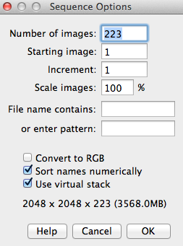

number of images matching *filename contains*

Optionally, scroll through the stack to see if any images are cloudy, affected by airplane trails, etc.  If so, you may want to delete those images.  To delete them, you can either delete the underlying file from the folder, or you can use the button with the red X, the leftmost button in the row at the top of the image display window.  If you delete the file itself, you may want to close the stack and reopen it. (If an observation is questionable, you may still want to leave it in, and after you produce your light curve you can track down suspicious looking data points…which very well may turn out to come from images that look bad.)

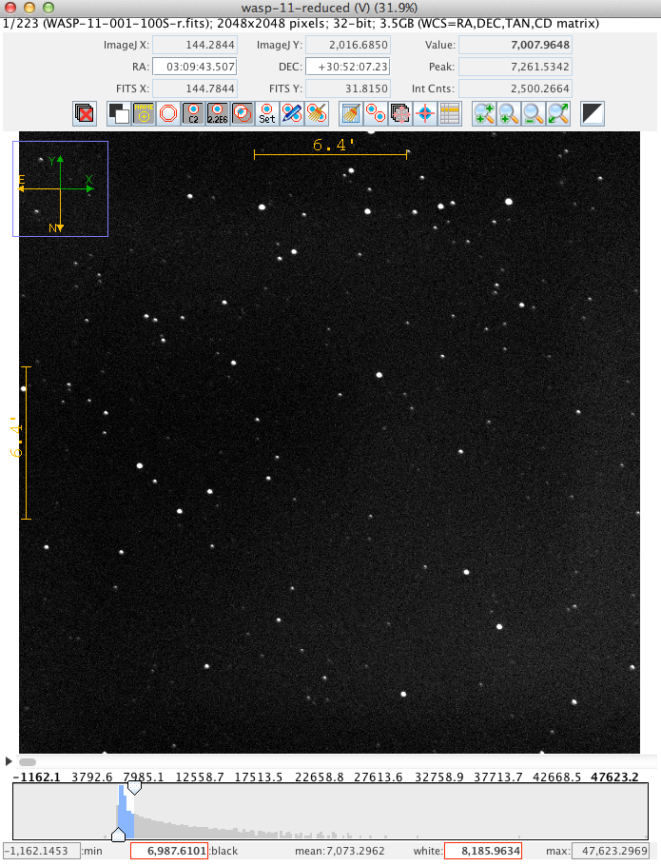

for deleting bad images

Note in this case, the image has north at the bottom (see yellow and green arrows/compass at upper left of the image). It’s not strictly necessary to fix this, but it will be convenient to do so. So, use the View → Invert Y menu option and then you should see North up and East to the left.

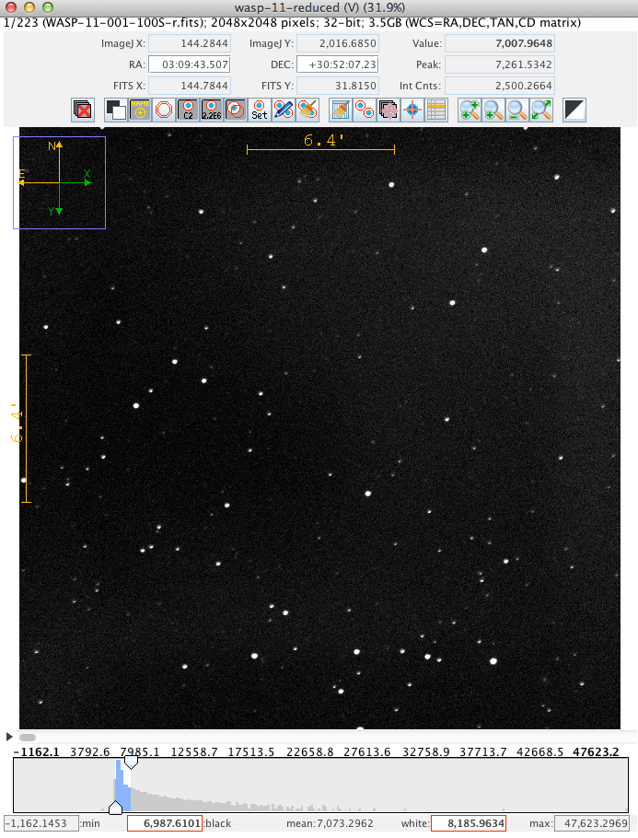

To figure out which star is our target, WASP-11, use the *Tapir* finding chart tool:

<http://astro.swarthmore.edu/finding_charts.cgi>

You can simply enter “WASP-11” as the Target Name and you should see a chart like this:

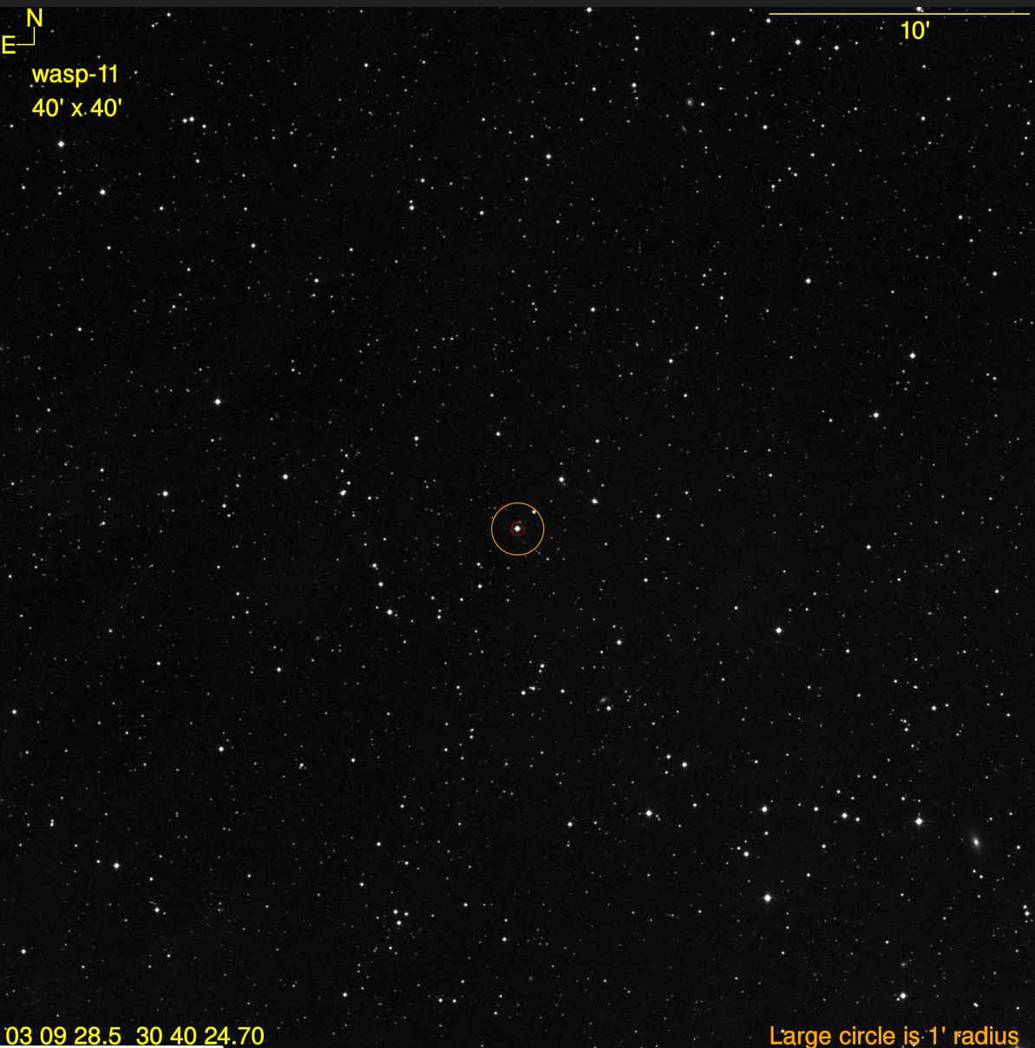

Comparing this finding chart to our image:

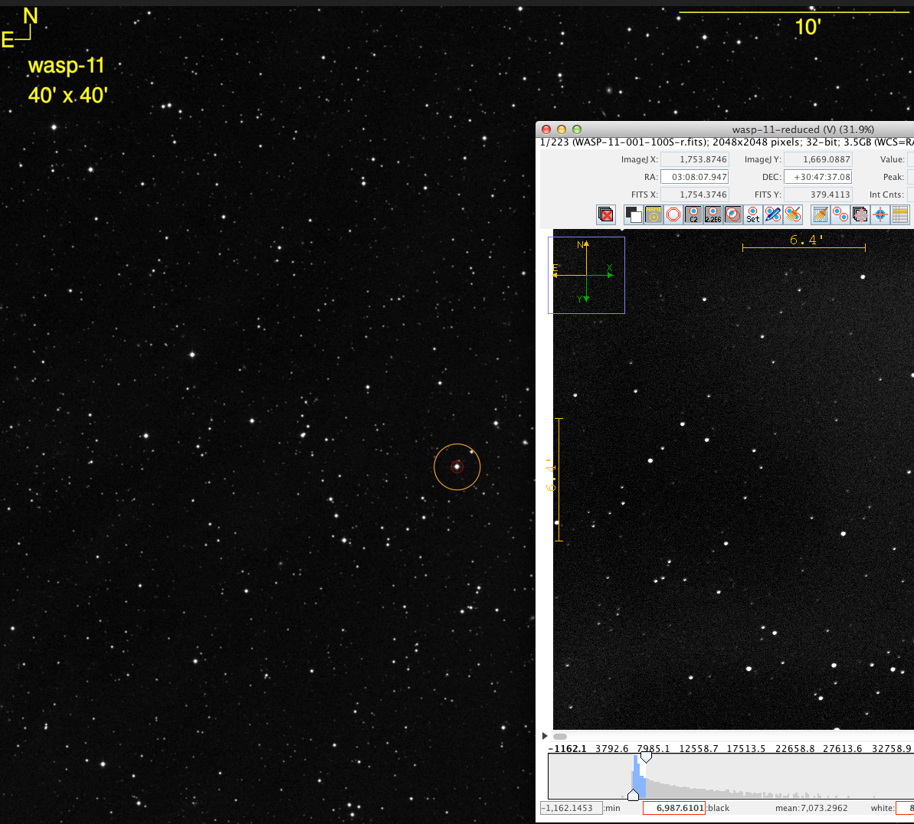

we can see that the target star is near the left edge of our images.

Next we examine the image to see if any stars are saturated, especially the target star. You can do this by moving the mouse around and pointing it to stars.  You will see a field labeled "Peak" at the top right.  Any value around 60,000 counts or above is probably saturated.   The brightest looking stars are the most likely to be saturated. In this image, none of the stars appear to be saturated.

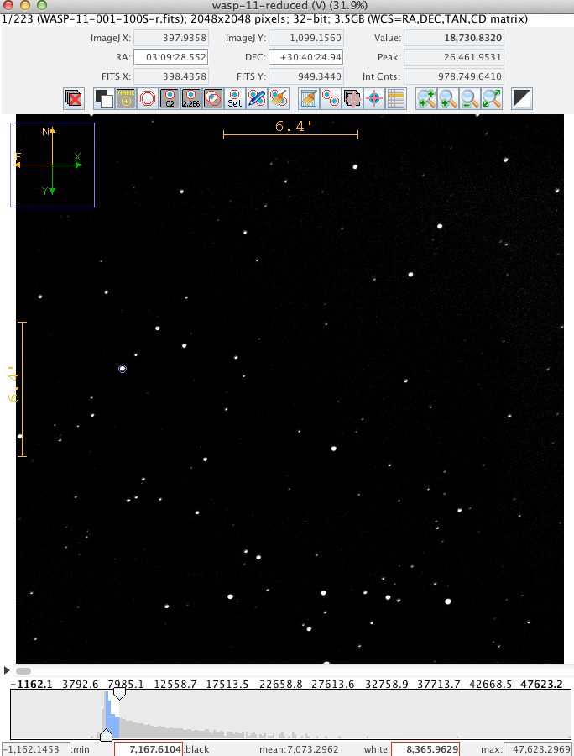

Here it appears that the target star (see faint circle around it?) has well below 60,000 counts. Even the bright star in the lower right of the image doesn’t have a count level that approaches 60,000.

Now that we have our reduced images in a stack, have identified the target star, and noted any saturated stars, we’re almost ready to do our photometery. This will involve having the software draw circles around the target and a number of user-chosen comparison stars. The software will sum up the counts inside each circle. It will also draw an annulus (ring) around the circle and sum up counts in that. That sky background counts per area will be subtracted from the source counts summed up in the circle. In this way, the number of background-subtracted source counts for each user-specified star in each image will be computed.

In order to determine the optimal circle (or *aperture*) size, we will want to examine the radial profiles of some of the stars in the image. To do this go to the main *AIJ* toolbar (not the one on the display window, but the floating palette), and choose the circle/ellipse tool (second from left, labeled “oval”).  Draw a small circle around a star that you think is *not* saturated (but one that is relatively bright).  It doesn't matter if it's perfectly circular.  Then choose from the main menu Analyze → Plot seeing profile.  It will pop up a dialog asking you to choose a radius in pixels - it usually suggests 50-75, but I usually decrease this to about 40 or so, which is plenty:

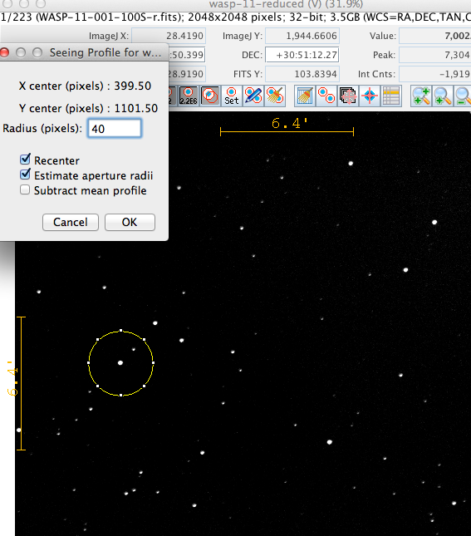

Once you hit "OK", you'll get a plot of the *radial profile* of the star, i.e. a plot of pixel counts as a function of radius from the center of the star.  *AIJ* will also choose some aperture size to encompass the starlight, and some radii farther out for measuring the sky. These are denoted “source” and “background” in the image below.

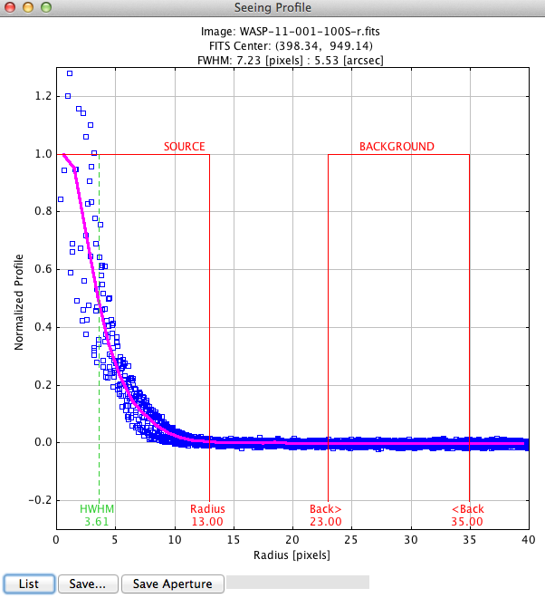

If you click the Save Aperture button these values will be remembered for when you do the photometry.  You should do this…unless things look weird (e.g. the source doesn’t look peaked; this one here doesn’t actually look so great, but I’m using it).

Now we are ready to do the photometry.

Click the icon in the toolbar at the top of the image display window that shows two red circles with light blue interiors (but without anything else overlaying the circles).  If you hover over this, it will say "perform multi-aperture photometry."

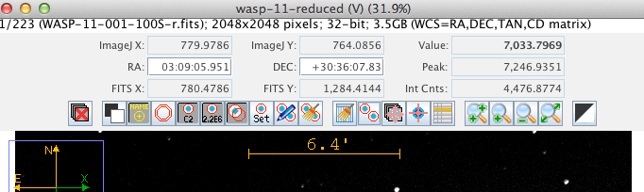

This will pop up a dialog that allows you to set various parameters for the photometry.  You should see that the aperture radii listed there are the ones derived from the seeing profile above - you can tweak them here if you want, but you probably shouldn't need to.  In fact, you probably don't have to change anything at all in this dialog - you can just click "OK". The one exception may be the “First slice” parameter, which you might want to have set to 1, and it might not be (its default is whatever image slice you’ve got open in the image viewing window).

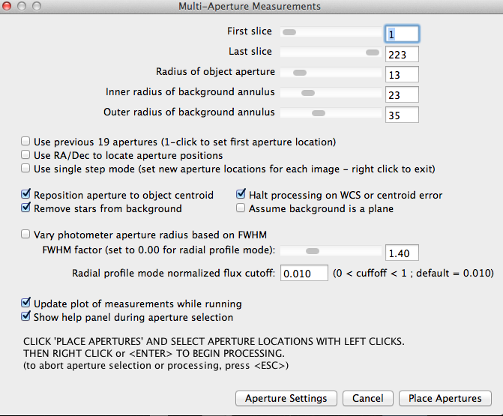

Make sure your check boxes are set as shown in the previous screen capture.

You will next click the “Place Apertures” button, and then on the image stack window, you’ll click on the target star, and then ten or so stars of similar brightness. These will be your potential "comparison stars".  You want stars that are relatively bright, but not saturated.   Remember, you can hover over a star to see its peak counts.  Also, avoid stars that have other stars very close to them. So, start clicking - choose your target star first, and then click on a number of other stars in the image as well.

The idea here is that conditions change from image to image (e.g. light cloud cover) affecting (ideally) all the stars in the image the same way. So to get our desired relative brightness of the target star from image to image, we will want to essentially compare the target’s (sky background-subtracted) brightness to an average of a set of well-behaved comparison stars – taking the ratio to correct for image-to-image sensitivity variations.

Each click will put a mark and annotation on your image:

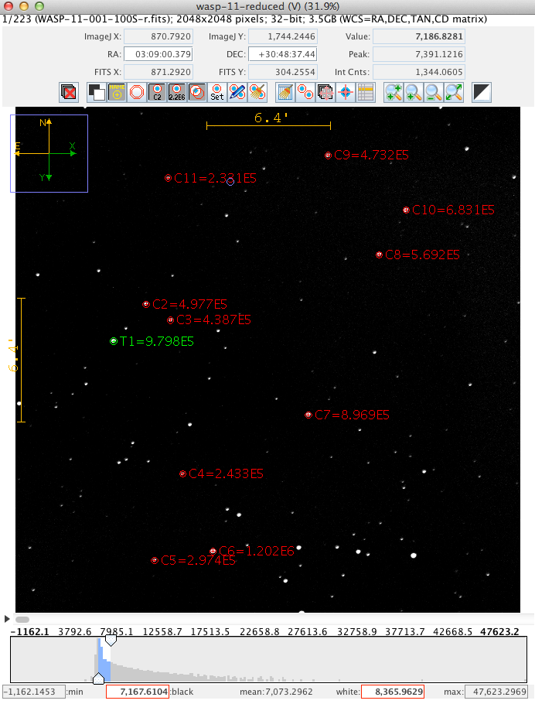

You don’t have to click exactly on the center of each star; the software will realign each circle (and so when those apertures are applied to each of the other images in your stack, it won’t matter if the images aren’t perfectly aligned – that’s why we don’t have to do the alignment process that we did do in the image processing).

When you've chosen enough stars, then either right click on the image, or hit Enter on your keyboard to stop choosing stars and start the processing.

Then *AIJ* will work through the stack of images, giving you entries in the log window.  When it's done, it will beep and pop up several other windows.

One window may already contain a pretty good looking light curve (especially if you made the target star the first star you clicked on – though don’t despair if your curve doesn’t look good/right – we’ll fix it up):

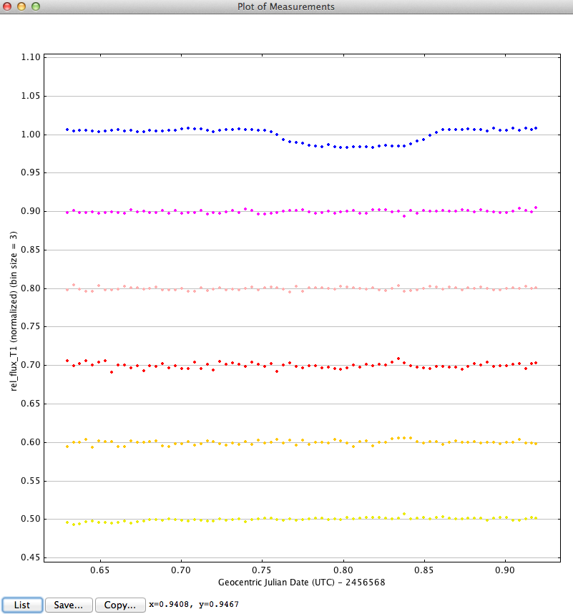

The blue curve is the target’s light curve (ratioed to the sum of all the comparison stars and then normalized so the average value is = 1.0). The other light curves are of the comparison stars. It’s encouraging that we see a transit like dip in the target star’s light curve while the comparison stars’ light curves are flat.

The window that looks like this:

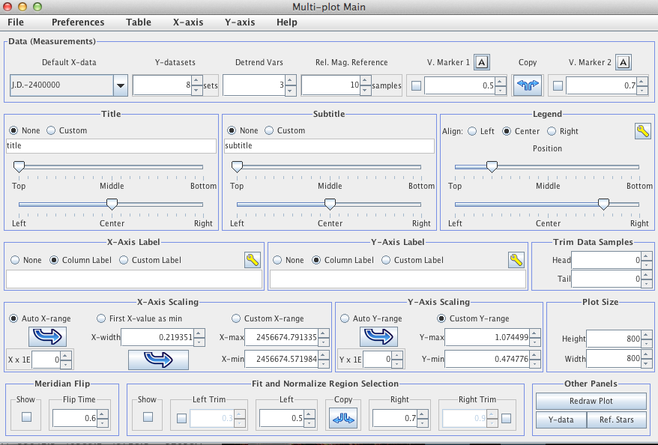

can be used to control the axis ranges etc.

The window that looks like this:

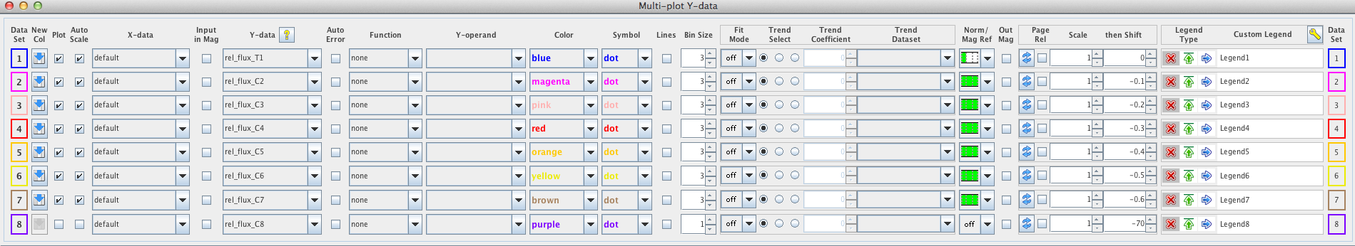

enables you to add more comparison stars to the plot, and controls some other aspects of the plot.

And this window:

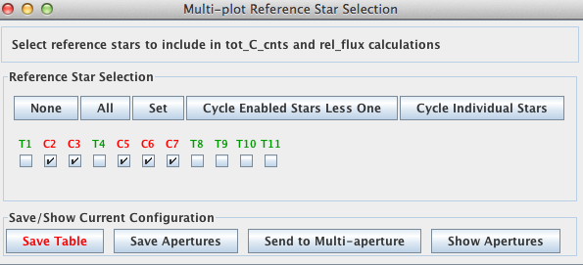

enables you to control which comparison stars are used for the ratioing with the target star. Potential comparison stars with noisy or variable looking light curves should be eliminated.

I also tweaked the normalization of the target light curve by adjusting the “Norm/Mag Ref” pull down menu for the target:

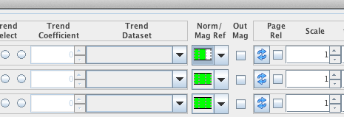

After doing that and eliminating some of the comparison stars, as shown at the top of this page, I adjusted the y-axis range and clicked the “Redraw Plot” button:

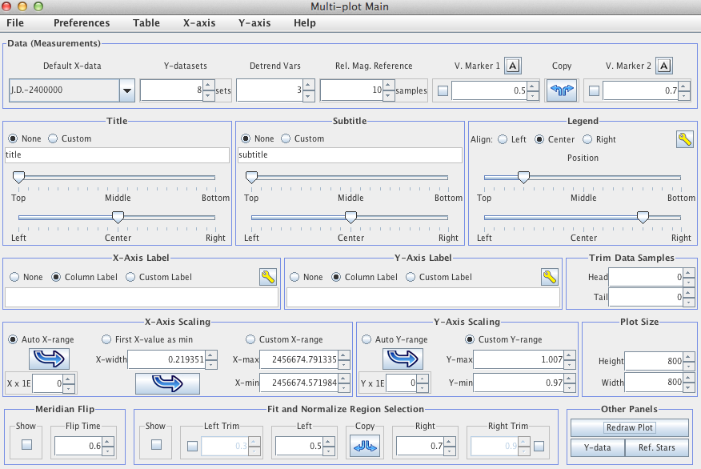

These steps produced this light curve:

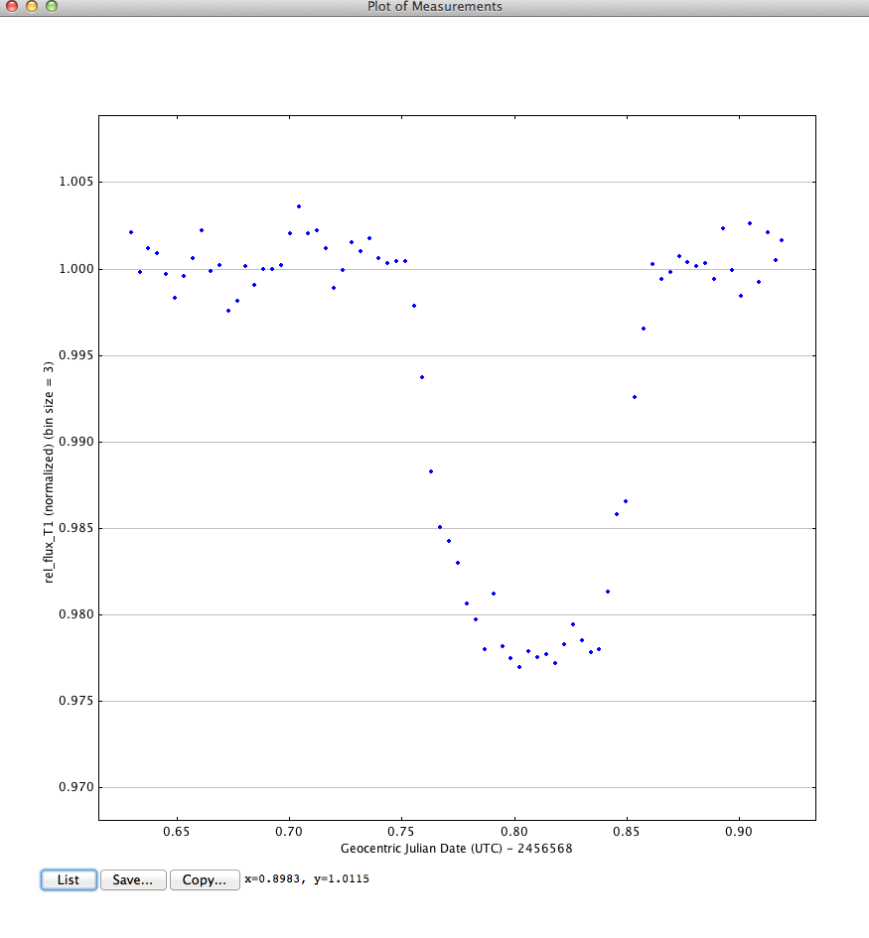

This is a pretty good looking light curve. The depth is about 2% (y-axis at 0.98) and the duration is about a tenth of a day (see the x-axis).

1. <http://astro.swarthmore.edu/~cohen/telescope/telescope_data_reduction_and_analysis_v1.0.1.pdf>